Unit 6: Transformations

Multiple Transformations

Answers

- The answer is c- a reflection across the room’s horizontal midline and a translation to the right

- The answer is a

a. 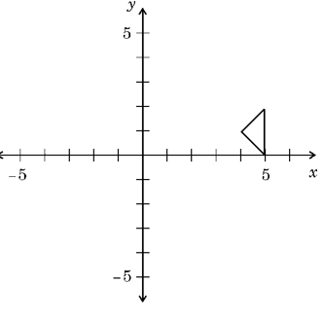
3. Using the following grid:

2 | 7 | 3
1 | 6 | 4
8 |  | 5
Move 6 down
Move 7 down
Move 2 right
Move 1 up

1 | 2 | 3
 | 7 | 4
8 | 6 | 5
Move 7 left
Move 4 left
Move 5 up
Move 6 right
Move 8 right

1 | 2 | 3
7 | 4 | 5
 | 8 | 6
Move 7 down
Move 4 left
Move 5 left
Move 6 up

4. Rotate the quadrilateral 90° clockwise about the origin and label it A´B´C´D´. Next, reflect A´B´C´ over the y-axis and label it A´´B´´C´´D´´. State the coordinates.

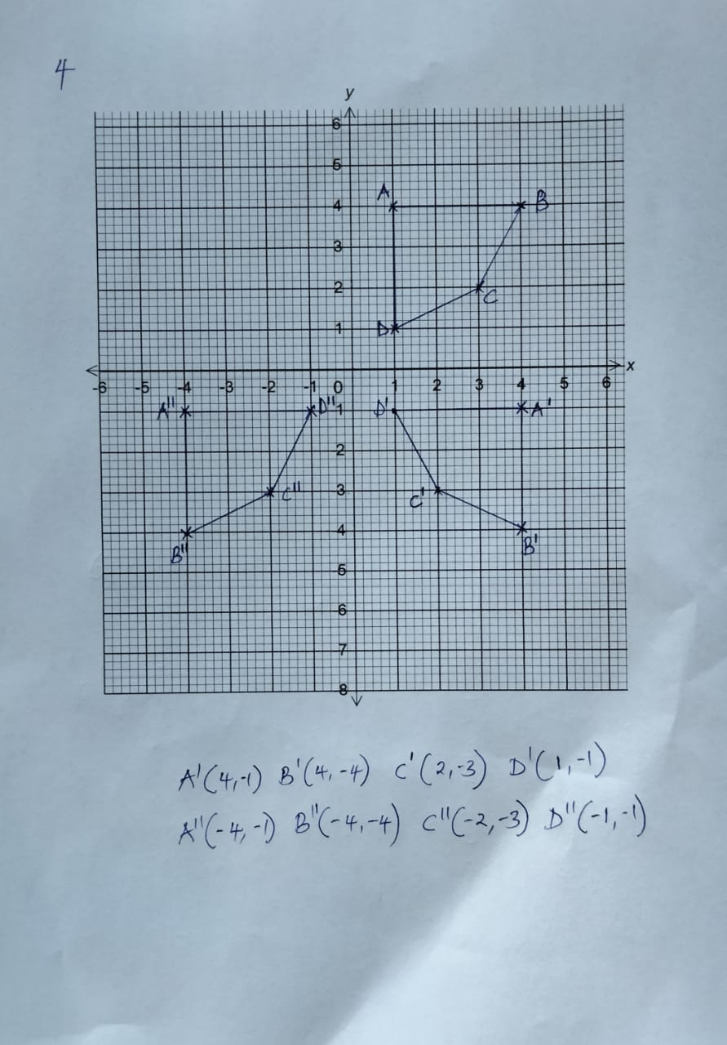

5. Use the following image for the next two questions.

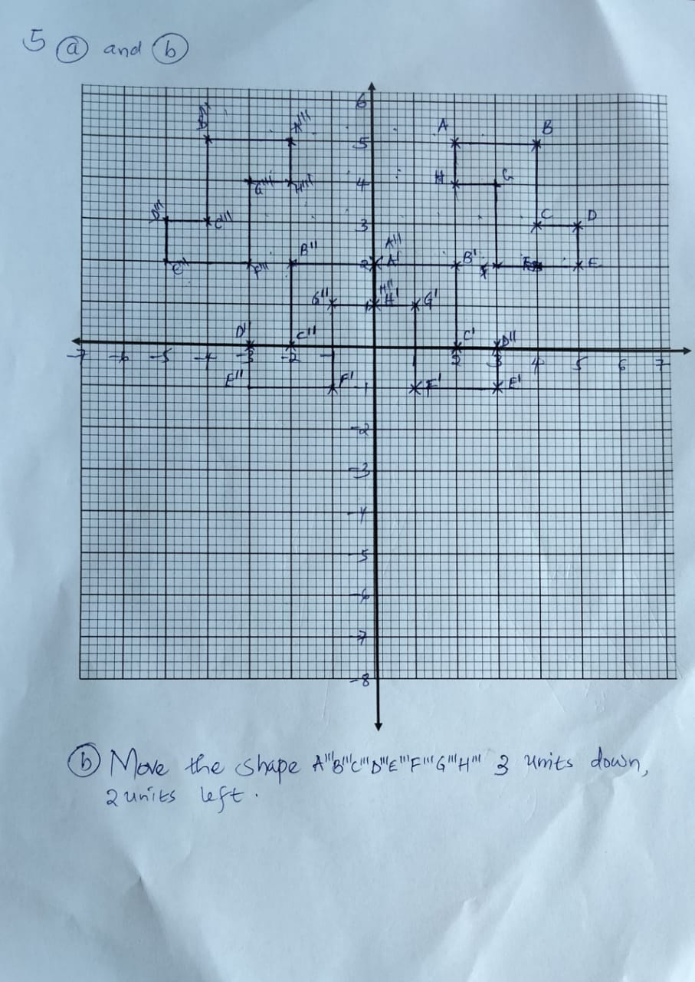

6. How many lines of symmetry does each image have?

Figure | Number of Lines of Symmetry
1 | 1
2 | 1
3 | 8
4 | 5
5 | 4
6 | 5
7 | 2
8 | 4
9 | 3
10 | 0
11 | 6
12 | 1

7. Fill in the following table

 | Coordinates | Scale Factor | Dilated Coordinates
a. | A(2,3), B(0,-5) | 4 | A’ (8, 12), B’ (0, -20)
b. | A (14, -8), B (-6, -12) | 0.5 | A’ (7, -4), B’ (-3, -6)
c. | A (-1, -1), B (3, 3) | 3.1 | A’(-3.1,-3.1), B(9.3,9.3)
d. | A(-15,0) , B(-5,10) | 0.2 | A’ (-3, 0), B’ (-1, 2)
e. | A (-2, -4), B (-2, -3) | 5 | A’ (-10, -20), B’ (-10, -15)

8. Is the dilation from Figure A to Figure B a reduction or an enlargement? Find the scale factor.

a. 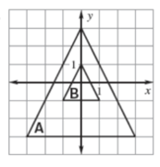
Is this a reduction or an enlargement? It is a reduction
What is the scale factor? S.F=$\frac{2}{ 6}=\frac{1}{3}=0.\dot{3}$

b. 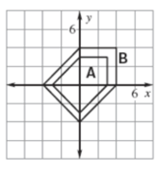

Is this a reduction or an enlargement? It is an enlargement
What is the scale factor? S.F=$\frac{2}{ 1.5}=\frac{4}{3}=1.\dot{3}$
9. In Math, the word dilate means to enlarge or reduce a figure. If a scale factor is less than 1, then your figure gets smaller. If a scale factor is greater than 1, then your figure gets bigger.

10. What 2 transformations have been applied to ABCD to create A’’B’’C’’D’’?

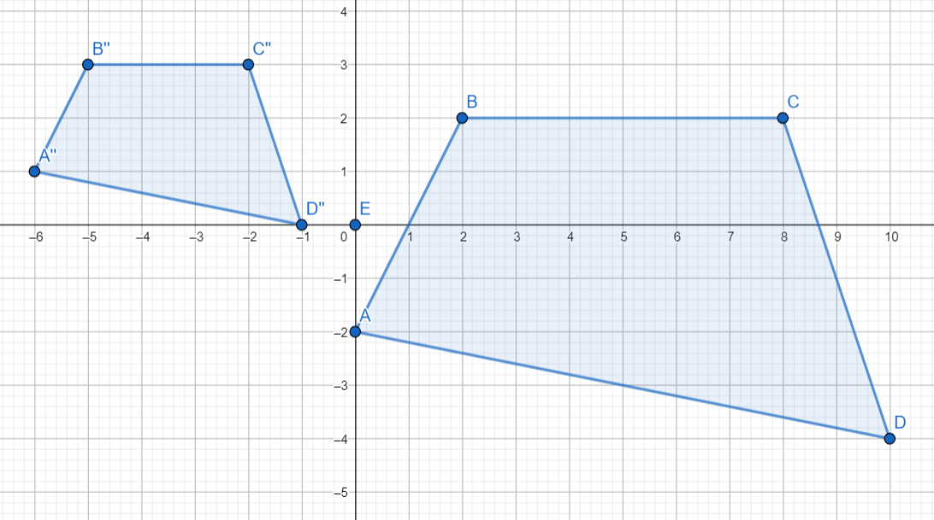
The transformations are;
- Dilation
Scale factor= $\frac{B^{'}C^{'}}{BC}=\frac{3}{6}=0.5$
- Translation
2 units up, 6 units left.

11. Describe the transformation.
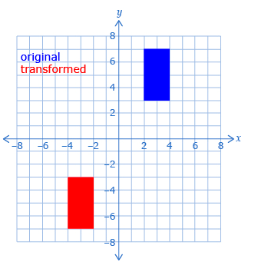
The transformation is Translation
2 units up, 6 units left.

12. Describe the transformation.
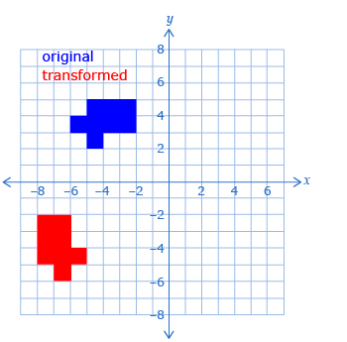

The transformation is Rotation of 90⁰ about the origin (0, 0)
followed by Translation 3 units left

13. Describe the transformation.
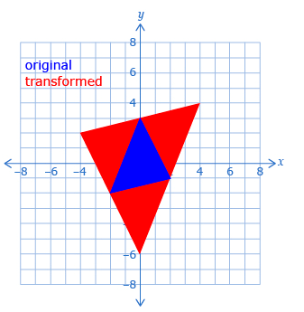
The transformation Dilation scale factor -2.

14. Describe the transformation.
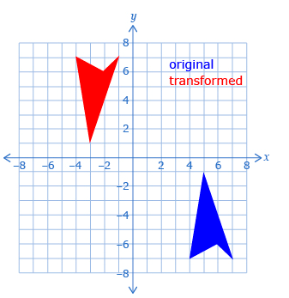

The transformation Translation 8 units left followed by Reflection in the x- axis

